**Name: Session:**

**Programming I**

**Lab Exercise 8.28.2024**

**Hello World**

The first thing you need to do before you can start writing computer programs is to learn how to setup your project. In this exercise, you will write a program that prints “Hello World!!!” in the programming environments we will use; Python. The purpose of this exercise is to walk you through setting up a project and getting your program to compile and execute.

**Hello World in Python**

1. Start Python using the IDLE interface.

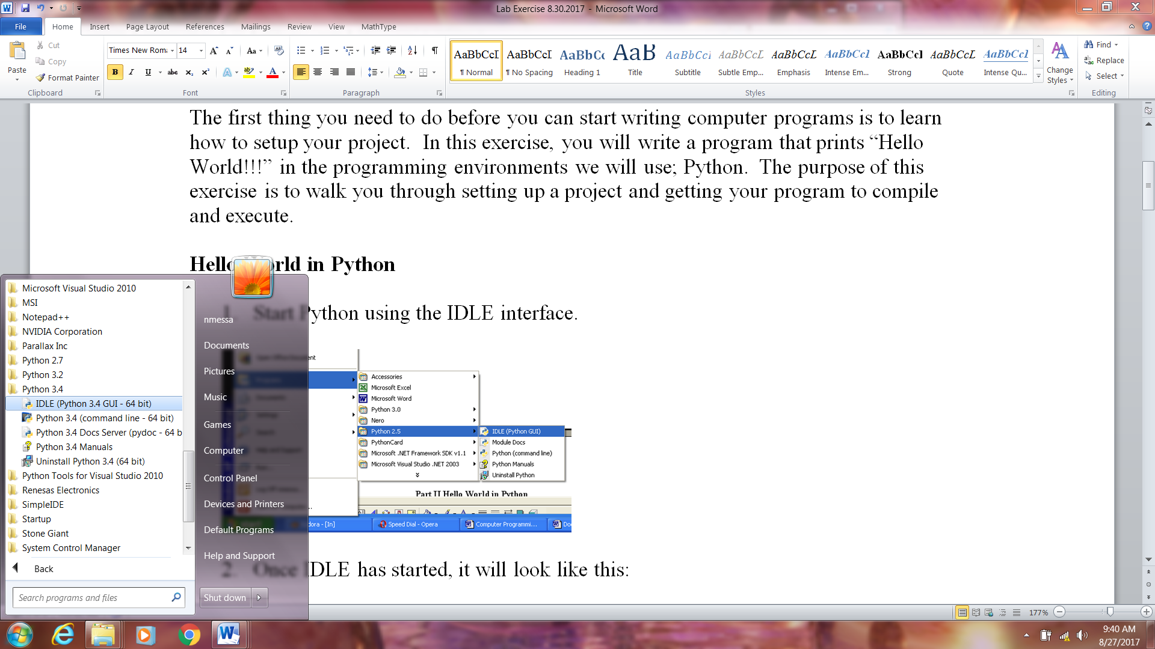

1. Once IDLE has started, it will look like this:

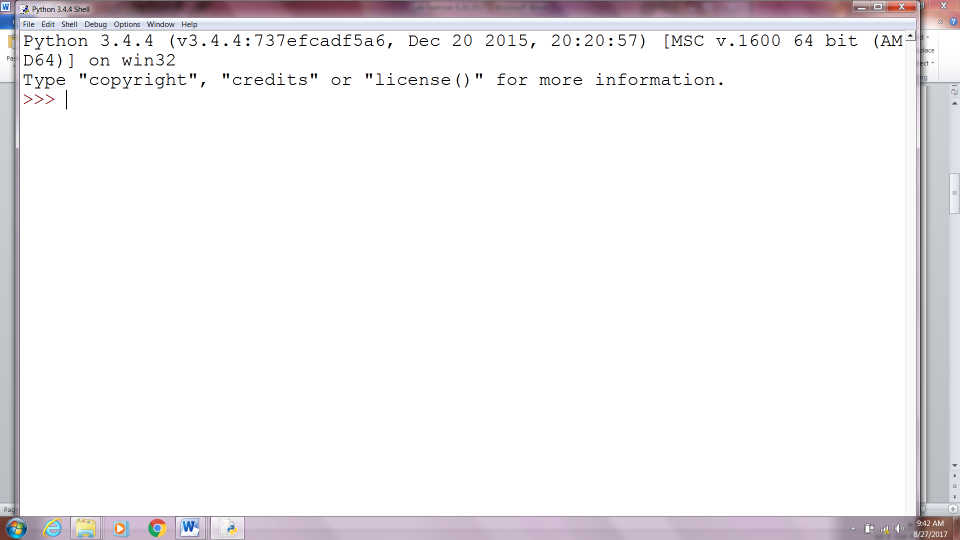

This is the Python Shell. We can get Python to execute instructions directly through this shell or we can create a separate program file.

1. There are two ways to get “Hello World!!!” to print. The first way is to just type:

print (″Hello World!!!″)

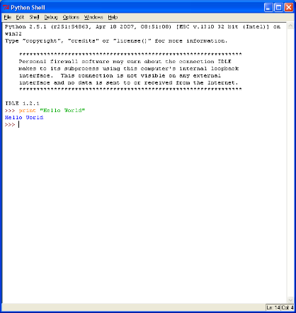

1. The second method is to create a separate program file. To do this, in the Python shell, select File|New Window.

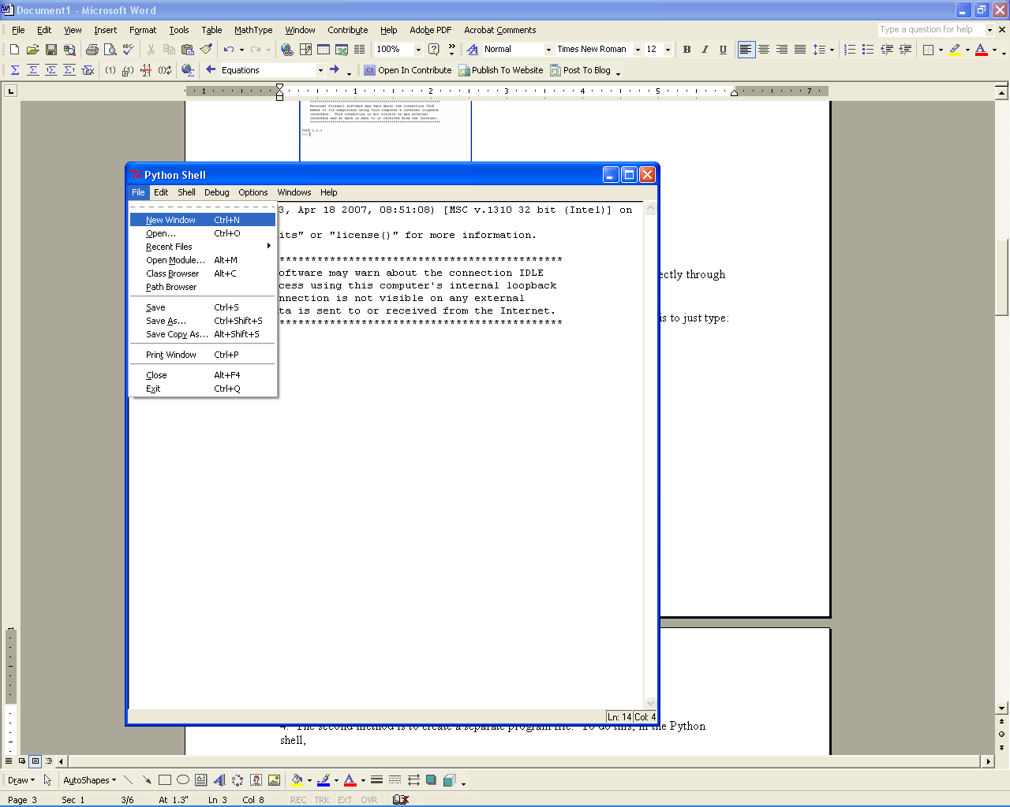

1. Type print “Hello World in the new window and save it as Hello.py

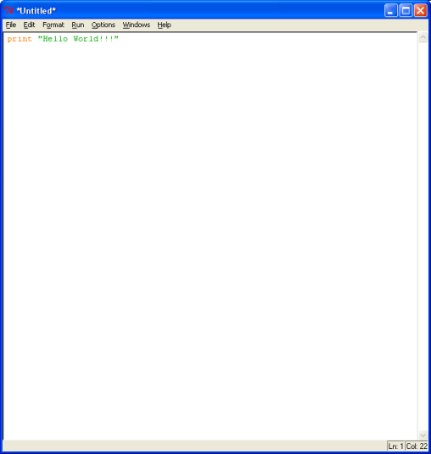

1. Select Run|Run Module (or hit F5) and you will see “Hello World!!!” appear in the shell.

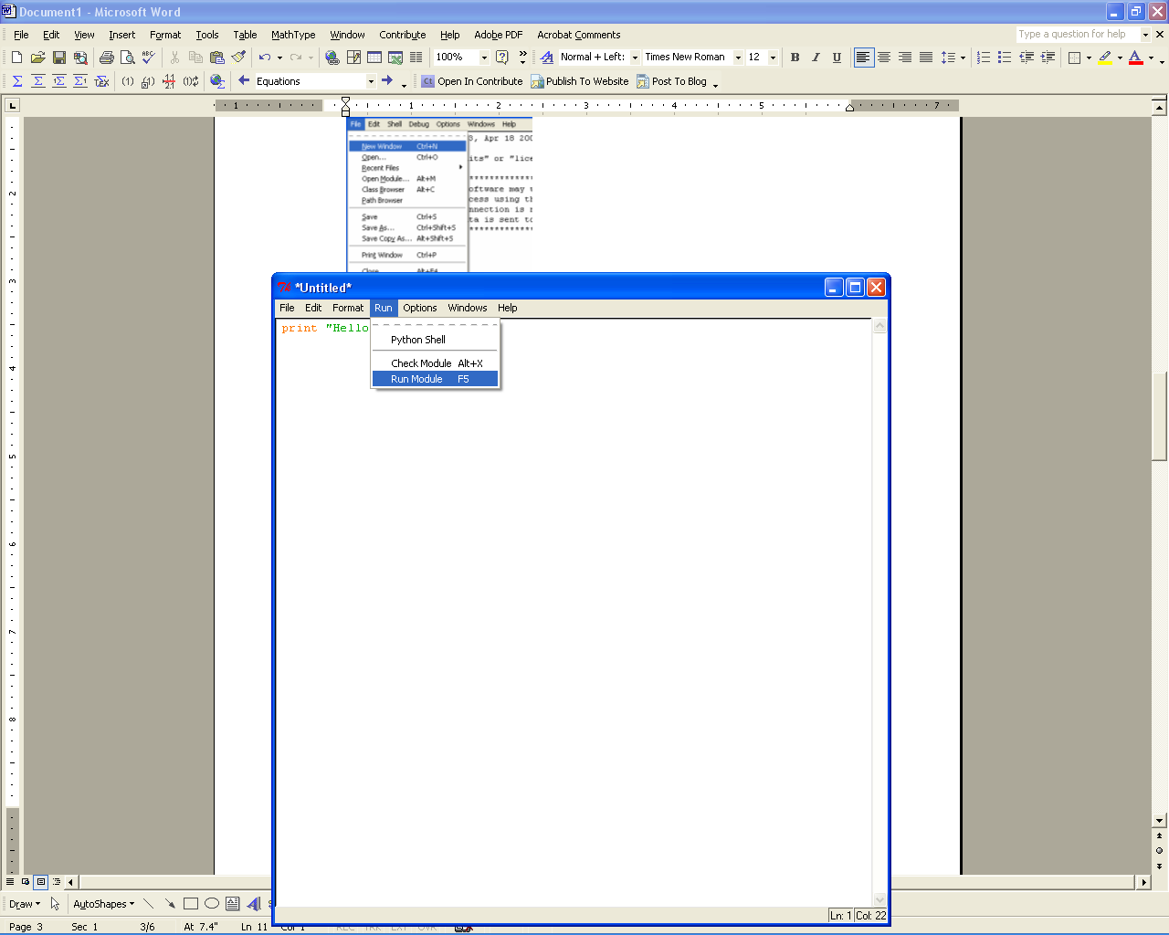

**Program Input and Output**

In Python 3 we have one function that will allow us to get user input into our program. This function is input. The input function will provide the program will provide the program with a string. Output from our program will use the print function.

1. Create a folder on your desktop called MyPython. We will be using this to organize all of your work. Each days project should have a folder inside MyPython labeled with the date of the assignment. For instance, this assignment should have a folder named **Lab Exercise 9.12.2020**.
2. Create a New Window and type in the following code:

name = input(“Enter your name: “)

print (‘Hello’ + name)

print (‘Hello’, name)

1. Create a program that prints your name, address, city, state, and ZIP code as provided by the user in the following format:

Jane Doe

13 Mockingbird Lane

Exeter, NH 03833

1. Write a program that asks you how old you are (in years) and then prints out how many seconds old you are.
2. Write a program to solve the following question. On Aug. 24, astronomers announced they had found a possibly Earth-like planet orbiting Proxima Centauri, the closest star to the sun. The planet, called Proxima b, is about 1.3 times the mass of Earth and is 4.22 light-years away.  How long would it take for the Proximans to get their MTV? How many miles is it to Proxima B? (Broadcast TV signals travel at 186,000 miles per second

**When you complete these four programs, submit your documented source code and attach to this sheet and turn in.**